Objects and Association

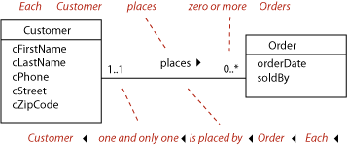

“Each customer places *zero or more* orders.” (* in the diagram below means “many”, and any quantity more than one is the same as “many” in a database.)

“Each order is placed by *one and only one* customer.” (Bad English—passive voice—but makes sense!)

 Looking at the *maximum* multiplicity at each end of the line (1 and * here), we call this a **one-to-many** association.